Please use the ED NACRS dataset found on Blackboard to answer the following questions.

- Using the Excel Analysis Tool Pack add-in, provide the summary statistics for patients registered (REG TIME) within the following bins:

- 00:00 – 08:00
- 08:00 – 16:00
- 16:00 – 00:00

Ans: Refer to attached excel

- A) Create a pivot table showing volume of patients by hour using REG TIME.
- Create a histogram of the results of 2 A).
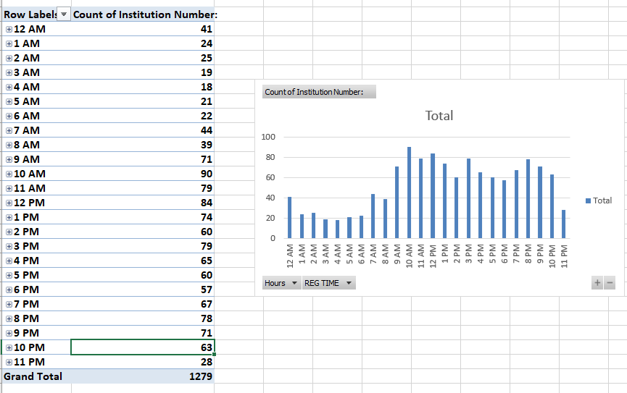

- A) Calculate # of patients date wise in each Triage Level.
- Relate each Triage level to diagnosis. You can do so list diagnosis against each triage level.

Ans: Refer to attached excel

- A) Relate each Triage level with Triage Time. Which Triage level has more triage time as compared to others.

Ans: Refer to attached excel

- List down some data quality issues related to NACRS dataset
Ans. Data has invalid values namely (**),missing values.

Upload the solution (word file only) on blackboard.

Please name the file: DAB304-LabWeek6 – Group#.
Example: DAB304-LabWeek6-Group63
Attachment:

